The Valuation of the Withdrawing and Expanding Option
Embedded in License Contract

Haruyoshi ITO ^{1*}, Kenji YAMADA ², Akane IWASAKI ³
¹ Keio University, Graduate School of Media and Governance
² Coteau Vert Co., Ltd.
³ Waseda University, Graduate School of Finance, Accounting and Law

Summary: In this paper, we intended to calculate the rational value of license contracts by real option approach which takes into account the value of expanding and withdrawing options which are not taken into account by previous method, DCF method, by using the case of business tie up between Le Coteau Vert Co., Ltd. (CV) and NORTHROP GRUMMAN Space & Mission Systems Corp（NGMS）related to the license contracts aboutμDISC Flex Filter. We calculate the rational value of license contracts by taking into account expanding and withdrawing option. In this case, we have to pay attention to how to sum up the value of expanding option and withdrawing one. In this paper, we use Monte Carlo Simulation method calculating rational value of license. This research surely help both managers who intend to invest in new business fields by purchasing license and licensor who sell and decide the rational value of license contracts. In addition, this research also help to decide rational compensation for damages related to patent which are concurrently occurred in the trial.
Key words：License, Real Option, Withdrawing Option, Expanding Option, Compound Option

- Introduction
In this paper, we pick up the case of business tie up between Le Coteau Vert Co., Ltd. (CV) and NORTHROP GRUMMAN Space & Mission Systems Corp (NGMS) about the license ofμDISC Flex Filter, which is technique used for Electronic Magnetic Compatibility. CV intended to use this technique for IT security business. Our purpose of research is to calculate the rational value of this license.
There are many papers which intend to calculate the rational value of patent such as license contracts. For instance, Schwartz[2001] is the most famous one, which use analytical approach to calculate the rational value of patent. In this paper, we use dynamic DCF approach, that is, simulation approach in order to calculate, and we adapt Cristal Ball to carry out simulation.
When we try to calculate the value of license, it is important to take into account the value of flexibility because the enterprise can withdraw from the business if it think the profit from the business will not be profitable after the license contract. Furthermore, if the companies think the business go well, they can invest in business related to previous business based on the license contract or can invest in foreign countries.
In this paper, we examine how much the value of license contract will increase when we take into account the option of withdrawing and expanding simultaneously and whether the value of license when we take into account both expanding and withdrawing option is different from the sum of the value of expanding option and withdrawing option.
In this paper, we firstly explain outline of the business of CV, which contracted license with NGMS in the second chapter. In the third chapter, we discuss how we evaluate the value of the license contract. In the fourth chapter, we explain the result of the calculation based on the theory mentioned in the third chapter and give insight from the calculation. Finally, in the fifth chapter, we explain our future research and how to improve our result.

2. Background of the License Contract
2.1．Contents and description of the license contract
First of all, the contents of license contract which CV got with NGMS (the exclusive production right of μ DISC in Japan and right of the sole agent ofμ DISC all over the world) are as follows.

The time of the license contract：January first, 1997
Duration：32 years（it is subject to renew the license contract）
The exchange rate at the time of the license contract：116 yen/ dollar
The license fee（consisting fixed part and variable part, which is proportion of the total sales）
Fixed part
1997～1999：150 thousand dollar（17.4 million yen）
2000～2028：200 thousand dollar（23.2 million yen）
Variable part（each year）：2% of the total sales

NGMS is the leading company of aircraft, space and trading in the U.S. CV got the license of μDISC Flex Filter from NGMS. This license allow CV to produceμDISC Flex Filter in Japan and to saleμDISC Flex Filter all over the world.
In the first first stage of negotiation with NGNS, CV cannot cancel the contract for 32 years, all term of the contract. However, afterward it became subject to renew the contract annually. In Japan, it is very uncertain whether CV is able to make profit from IT security business by using EMC technique. If CV cannot cancel the contracts for 32 years, CV will take very huge risks. From the perspective of this type of contracts, we can understand the value of flexibility which allows CV withdraw from the business. We determine the valuation method for withdrawing option.

2.2．Business Outline of Coteau Vert and its Business Plan
CV’s business and its business plan after the license contract are as follows.
1997 getting license from NGMS
1999 enterprising of handling noise by using EMC technique
2000 entering IT security business
2003 attestation by finger print business（entering to ACES business）
2004 CV successfully commercialized the attestation by finger print business
2007 CV invested in attestation by finger pricing business in foreign countries
2007 entering the Time Control business
The business related to the license of μdisc can be divided into three steps. The first step is handling noise business by using EMC technique and IT security business which CV began immediately after the license contract. The second step is the Access Control business using finger print attestation technique. The third step is the Time Control business which is expansion of the attestation by finger print technique.
After 1999, the time of enterprising based on the license ofμdisc, CV continued to research of TEMPEST (analysis of magnetic and electronic pulse by using electro-magnetic-waves) and applied its technique to IT security business such as countermeasure to a leakage of information from the computer by magnetic fields. All of techniques are based on existing μdisc technique. Accordingly, CV’s management and enterprise strategy is very suitable for the concept of real option.
In this paper, before discussing the calculation of license contract value, we discuss the nature of its license contract by comparing the financial data and CV’s business strategy. The financial data of CV is for the following by taking into account only the first step and the second step business for concise. That is, the second step business is the expanding option of the first step business. Therefore, we show only the financial data of only the first and second step business.
Table 1 The first step business (handling noise business by using EMC technique and IT security business)
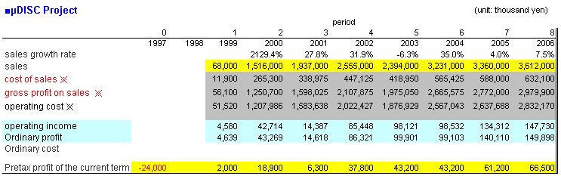

※ Indicated that these items are assumption based on the information from the accounting manager of CV.

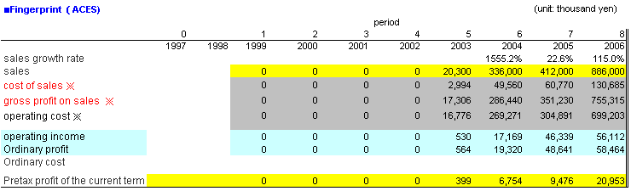
Table 2 The second step business (Access Control Business)

※ Indicated that these items are assumption based on the information from the accounting manager of CV.
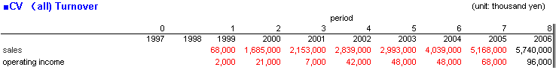
Table 3 The total sales and net profits of Coteau Vert

The sales are also shown in the figure listed below. This figure includes the sales prediction by Nomura Research Institute. This sales prediction are indicated in the report of analysis of the electro-magnetic-waves security business market.

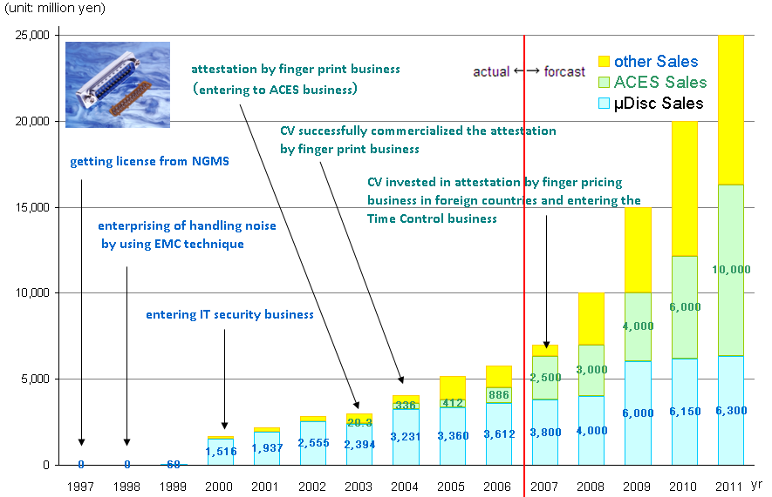

Figure 1 The CV’s sales, its prediction and the outline of business entry.
In the figure shown above, the whole length of bar graph shows the total sales of CV. In addition, the below part of bar graph means the sales of the first step business, handling noise business and IT security business by μ disc and the middle part of the bar graph means the second step business, access control business, which are appeared from 2003.
From the figure, we can understand that the sales in 1997 and 1998 are zero. In this period, CV contributed to find the manufactures which can produce by using the technique which CV got from NGMS. In 1999, CV were able to find the facilities which are able to produce commodities which are based on μ disc techniques, then CV enter the noise handling business which is the first purpose use of μ disc techniques.
Furthermore, CV’s sales in 2000 came to be 22 times lager than sales in 1999. They achieved this figure because CV successfully enter the IT security business by usingμ disc. At that time, IT security business partial aim is is the information leakage prevention from the way of electro-magnetic-waves for public facilities., Main sales is to public sectors.
In 2003, CV began to the Access Control Business by using μ disc. This technique tries to avoid invaders by using finger print attestation techniques. In 2002, CV started to research for commercialization of censor for reading finger print because the censor which was developed by NGMS is not suitable for commercial use. Finally, in 2003, CV successfully commercialized finger print business. In this finger print business, CV adopted pattern matching technique. This technique requires the calcluation by algorism which matches the finger print of people who try to enter and the finger print which are already recorded in the computers. In this calculation process, μ disc is applied.
In addition, in 2007, CV invested in Access Control Business in foreign countries and entered in the third step business which are not took into account the valuation in this paper. It is reasonable that CV will increase its sales based on the know-how, investment in foreign market and research and development not only for major customers but also for general public.
After 2008, CV will sale “comprehensive access control” as the third step business for major customers such as public sectors. This technique include the system which avoid the invaders not only by finger print attestation technique, but also from the fence and protective wall by usingμdisc license contract. Furthermore, not only for public sectors but also for general public, CV develops and sales service which avoids the strangers’ entrance by using electro-magnetic-waves. CV also develops comprehensive patrol system based on existing control know-how and products and carry out research and development in order to get new clients by satisfying their needs for control access. Consequently, CV’s license contracts have big value of expanding option.
All of business are based on the license of μ disc which CV got from NGMS. It is understood that the license contract have great value of expanding option despite the single μ disc license.
However, for concise, in this paper we take into account only the second step business as an expanding option to the first step.
Making advance in the next step business, there are many types of uncertainty such as the demand for the service, whether CV can successfully enterprise the business idea, and successfully develop the know-how and commercialize the business. We determine the quantity of these risks and calculate the value of license contract by taking into account the decision making of expanding the business.

3. The method of valuation of Expanding and Withdrawing Option
In this paper, we calculate the value of the license contract by taking into account both withdrawing and expanding option. We calculate the value in both deterministic case and uncertain case. First of all, we calculate the value in the deterministic case. In this case, we estimate the future cash flow from the business and then discount future cash flow. Finally, we calculate the present value of the license. In the uncertain case, we made the model which estimates the future cash flow which have stochastic process by taking into account uncertainty of the future sales. Finally, we clarify the criteria of exercising withdrawing and expanding option.

3.1．Calculation of Free Cash Flow (FCF)
The way of calculation of FCF is the following.
・Sales×(1－the cost of sales / sales)＝Gross Margin
・Sales Administration Cost＝R&D＋the other operating costs
・R&D＝Sales×R&D (variable)/Sales＋Fixed costs
・The other operating costs＝Sales×the rate of the cost of the other operating costs (the other operating costs/sales)
・Operating profit＝Gross Margin－Sales Administration Cost
・NOPAT＝Operating profit×（1－tax rate）
・FCF＝NOPAT＋Amotization－invested capital－increasing of working capital
In this paper, we assume that invested capital and increasing of working capitals zero.
The parameter we used are shown in table 4. In terms of the sales, we will mention in chapter 3.3.

Table 4 The parameters used for the calculation of FCF
Items | First  (μ disc) | Second  (finger print)
The cost of Sales / Sales | 17.5％ | 14.75％
R&D(variable) / Sales | 25.0％ | 27.0％
Fixed Cost | 10 mil yen | 20 mil yen
The other operating cost  / Sales | 52％ | 55％
Amortization | 17.4 mil yen | 0 yen
Tax rate | 40％ | 40％
We present its parameters in Table 4, as follows:Cost of sales / sales and Amortization, we used CV’s official notice data. Cost of R&D, CV do not open the data. We assumed that CV’s cost of R&D equals that of the similarly situation companies. In general, the rate of R&D costs to Sales of electric industry is 6.7% and the medical industry has higher R&D costs. In the later one the highest rate of R&D to sales is 43.90%, minimum case is 13.53% and average case is 23.61%. We have assumed that its investment in R&D would be similar to medical industry, because CV is IT venture company and R&D is vital to survive by producing and developing competitive products. Then, we estimated high R&D ratio, that is, 25% for the first step business and 27% for the second step business. In addition, R&D cost is decision making variable and R&D will vary corresponding to the management situation. However, for simplifying the model, we assume R&D ration (R&D costs / sales) is constant.
Amortization means that the initial cost is amortized equally in 20 years.

3.2．The valuation of license contract under deteministic assumption
The lisence contract are evaluaeted for the following.
${\text{NPV}}_{0}=−I+\sum_{t=1}^{\text{32}}{\frac{{\text{FCF}}_{t}}{{\left(1+r\right)}^{t}}}$
(1)

Here, ${\text{NPV}}_{0}$ is the value of license (enterprise value related to license contract), subscript of 0 is the time 0. $I$ is investment, in this case, the amount of the investment is 34.8 million yen, which is initial cost of license contract. ${\text{FCF}}_{t}$ is the free cash flow at time t. $r$ is the cost of capital.
We calculate the cost of capital for the following CAPM framework. In this case, we calculate the cost of capital by calculating expected return on capital of NGMS. As we mentioned above, NGMS invest in CV and have 50% of its shares, thus the method of calculation of costs of capital is rational. In addition, CV do not owe any debt, namely, costs of capital equal weighted average cost of capital.

$r=r_{f}+\left(r_{m}−r_{f}\right)β$
$β=\frac{\text{Cov}\left(r,r_{m}\right)}{\text{Var}\left(r_{m}\right)}$
(2)

Here, $r_{f}$is risk free rate at the time of the license contract. We adopted 10 years U.S. national bond (6.148) as of January 1997 as a risk free rate. $r_{m}$ is rate of return of the market portfolio. In this paper, we adopted DOW index in NYSE as a market portfolio. We calculated return on capital by using monthly data from January 1992 to December 1996. As a result, the rate of capital of the market portfolio is calculated as 14.641%.
$β$ is calculated by using monthly data from January 1992 to December 1996, that is five years data. $β$ is calculated as the result of covariance of return on capital of the market portfolio and rate of return of NGMS stock / the variance of rate of return of the market portfolio. As a result, $β$ is 1.1. It can be inferred that NGMS’s systematic risk is slightly higher than the market portfolio.
By using parameters we mentioned above, the cost of capital of shareholder’s equity was calculated as 15.471%.
By following the assumptions we mentioned above, in the deterministic case, the license contract value was 157 million yen.

3.3．Introduction of uncertainty
In addition to the analysis under deterministic assumption in the chapter 3.2, in this paper, we introduce uncertainty in order to calculate rational value of real option embedded in license contracts. We assume uncertainty in the sales, growth rate of sales, success rate in the new busniess fields and success rate in commcercilization. We assume triangle distribution (minimum, mode, maximum) in the sales and growth rate of the sales.

- The sales（at the first year of entrance in the business）
（50 million yen, 75 million yen, 100 million yen）
- μ disc’s growth rate of sales
2001～2004：（－10％, 20％, 50％）
2005～2011：（－5％, 10％, 15％）
・The grow rate of the salese of ACES business
2004～2011：（－20％, 20％, 60％）
・The probablity that CV is able to successfully enter IT security business based on noise hadling business by EMC technique：80％
・The growth rate of sales if the CV is able to successfully enter in IT security business at the first year
（1,000％, 1,500％, 2,000％）

Furthemore, we introduce correlation coeficient between the growth rate of the sales at the time of t and the growth rate of the sales at the time of t-1. In addition, we also assume the correlation coefficient between the growth rate of the first step business and that of the second step business. These assumptions are rational because in real business, the business tends to go well at the following year when the business goes well at the first year. Furthermore, we introduce correlation coefficient between the first step business and the second step business because both businesses are related to security and both businesses require similar technique such as pattern matching technique. Therefore, it is reasonable to assume that the first step business and the second business have correlation in terms of whether both businesses have demands in Japanese market.

・The posibility of commcercilization after entrance in ACES business
We assume that the research term for commcercilization is three years and the probability that CV can successfully comercialize the business in a year is 42%. Therefore, the probability that CV can commercialize the business in three years is 1－(1－42％)³＝80％.

・The probablity that ACES business go well in foreign market
CV has prepared for foreign market since 2007. In this paper, we assume that CV will start business in foreign market in 2007 and the success rate of this business is 50%. If the business goes well, we assume the growth rate of the sales as（100％, 150％, 200％）. If the business does not go well, the growth rate of the sales is（－20％、20％、60％）.

3.4．A Decision Criteria
In this paper, the modeling the criteria of exercising withdrawing and expanding option is important. First of all, the decision criteria of each option are for the following.
・The exercising criteria of the withdrawing option
When the enterprise value which is calculated by concise method is positive, CV do not withdraw from the business and if that is negative, CV withdraw from the business.
Left hand of below equation is concise method of valuation of enterprise value, right hand of the equation is the enterprise value by DCF method.
$\frac{{\text{FCF}}_{t}^{i}}{r−g_{t}}=\sum_{h=1}^{n}{\frac{\left({\text{FCF}}_{t+h}^{i}+{\text{FCF}}_{t+h}^{j}\right)}{{\left(1+r\right)}^{h}}}$
(3)

${\text{FCF}}_{t}^{i}$ is the free cash flow at the time t when the decision will be made. Superscript i means the first step business (IT security business) and j means the second step business (ACES). If the profitability of IT security business is low and if ACES business’s profitability is higher than IT security business, it is not better to exercise withdrawing option. Then, we determine that when the summation of enterprise value of both step business is positive, CV do not withdraw from the business and when the summation of enterprise value is negative, CV withdraw from the business. $r$ is cost of capital, $g_{t}$ is the growth rate of the free cash flow. $g_{t}$ is determined as the enterprise value by concise method equal to the enterprise value by DCF method in deterministic assumption. Therefore, the growth rate will differ in each term and each growth rate has subscript t. If the left hand of the equation is positive, CV continue to go on business and if the left hand of the equation is negative, CV withdraw from the business. Furthermore, the decision of withdrawing from the business will be made after 2001.
・The exercising criteria of expanding option
If the enterprise value of ACES by concise method is positive, CV invest in the second step business and if that is negative, CV do not invest in the second step business.
$\frac{{\text{FCF}}_{t}^{i}}{r−g_{t}}=\sum_{h=1}^{n}{\frac{{\text{FCF}}_{t}^{j}}{{\left(1+r\right)}^{h}}}$
(4)

The calculation method is similar to the decision criteria of withdrawing option. However, we use the free cash flow from the IT security business in order to evaluate the enterprise value of the second step business (ACES). That is, we assume it is possible to estimate the free cash flow of ACES business by using the cash flow from IT security business.
In addition, in terms of the second step business, as we mentioned above, if CV is not able to commercialize the second step business, CV withdraw from the second step business and if CV is able to commercialize the second step business, CV do not withdraw from the second step business.
Furthermore, the reason why these decision criteria are needed is that compatibility between the Monte Carlo simulation and valuation by real option method is not suited. If we use the future cash flow which is generated by Monte Carlo simulation in order to evaluate the enterprise value for decision, it means that we can perfectly estimate future cash flow as of the time of decision. That is, in the simulation, we made the distribution of the enterprise value by discounting the future cash flow in each path. Again, if we use the enterprise value by the simulation, we are able to know which path realizes and we are able to make decision by the path which will realize in the future. We are able to know which path will realize perfectly as of now. Then, by using this value is not reasonable to make decision. (If we can estimate future cash flow perfectly, it is reasonable method, but it is also true that real option analysis has no mean.) Therefore, it is required to make decision criteria by using enterprise value other than the valuation for the license contract. For this valuation for decision making must be carried out by using the date which is available as of the decision making. Then, in this paper, we used the cash flow as of the decision making in order to calculate the value which is used for decision making. Furthermore, in order to include the information of the estimation of the future cash flow, we calculate the growth rate of the sales under the deterministic case, and calculate the value for decision making by using this growth rate.

4. The value of license contract with or without withdrawing and expanding option

4.1．The value of withdrawing and expanding option when given the correlation coefficient between the first step business and the second step business
The value of lisence contract is shown in table 5 under the assumption we mentioned above. For comparison, we calculate the vluae of the lisence contract when we do not take into account the expanding and withdrawing option.

Table 5 The value of the license contract in each case
Withdrawing  Option | Expanding  Option | Value  (thousand yen) | The probability that NPV is negative
× | × | 81,622 | 22.0％
○ | × | 92,044 | 22.0％
× | ○ | 82,559 | 22.0％
○ | ○ | 92,044 | 22.0％

Both withdrawing and expanding option, the license value improve 10,422 thousand yen than when neither is applied.. This difference means the value of the flexibility of the management.
Only withdrawing option, its value is 10,422 thousand yen.
Only expanding option, its value is 927 thousand yen. The value of the license contract is not arithmetic summation of driving both withdrawing and expanding option for the reason that the exercising of expanding option depends on the exercising of withdrawing option. That is, if CV drive withdrawing option, CV is not able to exercise expanding option and its value will be 0. In other words, the flexibility is limited and the value of flexibility is decreasing. Furthermore, in this paper, if the CV do not exercise the withdrawing option, CV always exercise expanding option. The value of flexibility disappears and the value of the license contract by taking into account withdrawing option is the same regardless the existence of expanding option.
It is probable that companies have many options, however, the enterprise value is not the simple sum of the value of these options because each option relates in complicated manner. Furthermore, in order to estimate the enterprise value rationally, we need to calculate not only the value of each options but also model the relationship among each business underlain the option value, the relationship between the decision criteria of each option.

4.2．The value of license contracts when changing correlation coefficient
In chapter 4.1, we assumed the correlation coefficient between the first step business and the second step business is 0.4. In this chapter, we analyze the value of withdrawing and expanding option when changing correlation coefficient.
The value of license contract by assuming correlation coefficient is as follows.
Table 6 The value of the license contract when changing correlation coefficient.
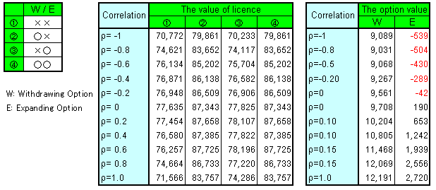

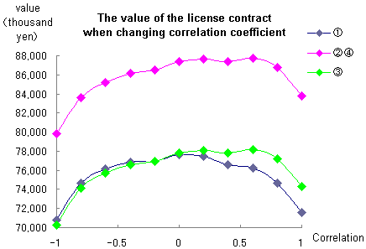

Figure 2 The license value when changing correlation coefficient
As can be seen in Table 6, the value of the license do not increase corresponding to that the correlation between the business increase. We break the value of license into option value and intrinsic value (license value without option).we can understand that the option value increase corresponding to the correlation coefficient. That is, that the value of the license contract decreases is caused by the decreasing of intrinsic value of the license.
The reason why the intrinsic value of the license decreases is that the distribution of the enterprise value is not symmetric, because the distribution of sales have relatively fat tale in left side. That is, the probability that the sales growth results in minus is higher than that results in plus. Therefore, if we assume the correlation coefficient is 1, the probability that the sales growth is minus increases. The value of the license decreases though the option value increases.
Furthermore, if there is no flexibility in management decision, the value of the license contract is the highest when correlation coefficient is 0. However, if we take into account the flexibility of the management decision, the value of the license contract is the highest when the correlation coefficient is 0.6, because the option value increase depending on the correlation coefficient. From this result, in the diversification strategy for the enterprises, it is better to invest in the business whose correlation with existing business is higher because the company can use know-how the company have already acquired for the long term from the view of increasing enterprise value. However, in term of the venture business, it is probable that the distribution of the enterprise value and future cash flow leans to left side (minus side). Then, to invest in the business whose correlation is too high is not good idea because the enterprise value will decrease as shown in the figure above. Therefore, when the company makes investment strategy, the company need to carry out analysis of cash flow and enterprise value.
In addition, as shown in the figure 3 and figure 4, the option value is increasing corresponding to the correlation coefficient. It is because that in our model, when the coefficient is high, the relationship between the cash flow from existing business and cash flow from the second step business become more intense so it become more probable that making decision following the cash flow from existing business is rational. Withdrawing option, when the correlation coefficient is high, the opportunity loss such as withdrawing from the business though the enterprise value would be high if they continue the business is decreasing. Expanding option, if the correlation coefficient is high, it became more probable that exercising the expanding option realizes high enterprise value than not exercising expanding option.
As we discussed above, we analyzed the value of the license by changing correlation coefficient between the first step business and the second step business. We can conclude that to invest in business which have some relationship with existing business is more reasonable than in the business which has no relationship because the company can use know-how and make good use of strength of the company and the company can improve its enterprise value.

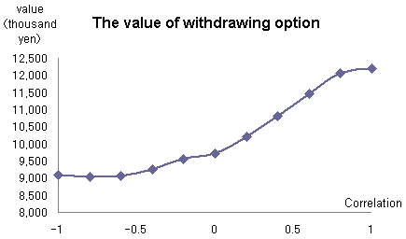

Figure 3 The value of withdrawing option

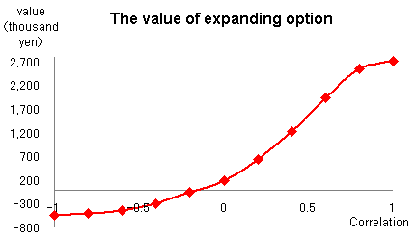

Figure 4 The value of expanding option

5. Conclusion
In this paper, we carryied out the valuation of license contract by taking into account both withdrawing option and expanding option by simulation.
As a result, we were able to show the lisence value by driving both options is actually higher than the valuation by DCF method, which cannot handle the value of management flexibility as the option theory already shows. We are sure that if these valuation methods by real option theory can be applied in real business, companies can invest their money in more risky projects because real option theory gives more rational value than DCF method.
We also analyze whether the value of license changes when the correlation efficient changes. By this analysis, we can conclude that to invest in the business which has some relationship with the existing business is more reasonable than in the business which have no relationship because the company can use know-how and make good use of the strength of the business the company built for a long time. Using this investment strategy, the company can improve its enterprise value. Therefore, diversification strategy and M&A strategy which intend to invest in the business whose correlation with the existing business is higher is better strategy than haphazard diversification strategy because the company can improve its enterprise value.
Furthermore, in the valuation of financial option, the possibility of the loss after exercising option is not on supposition. However, in reality, the company do not exit immediately after the investment in the business. If we try to apply real option approach, we have to consider the probability of loss after exercising option. In this paper, in any cases, there is some probability of loss. However, by taking into account the flexibility of the management, the enterprise value increases because the company can avoid huge loss. The enterprise value also increases by the expanding option because the company do not invest in the second step business if its profit is low.
For the future research, we can improve the decision criteria. For instance, in terms of the American option, which can be exercised before the maturity, it is not reasonable to exercise the American option anytime when it is in the money. That is, in this case, it is not always reasonable to invest in the second step business when the NPV is positive. We have to consider what kind of situation is the best time to invest such as how much amount of future cash flow is estimated or how much enterprise value realizes. In this paper, we determine the decision criteria by calculating the enterprise value by using a single fiscalyear cash flow as a concise method. We are sure that we can contribute to companies to make excellent management strategy which can realize higher enterprise value by calculating rational value of real option in the management strategy by offering more sophisticated decision criteria.
Finally, it is important to make decision by using real option method. In the future, we continue to research about the rational valuation in order to contribute to the real business by making more rational decision criteria and offering more applicable method to real business.

Bibliography
- Kato, Atsushi, 2007, Real Option and IT business (Japanese) Economist Co., Ltd.
- Mano, Yuji, Naoya Takezawa and Nobuya Takezawa, 2006, Sekiyu Kagaku Kougyou ni Okeru Sougyou Chuushi option ni Kansuru Jirei Kenkyuu, (Japanese), Real Option and Management Strategy, 279-300.
- Panayi, Sylvia, and Lenos Trigeorgis, 1998, Multi-stage real options: The cases of information technology infrastructure and international bank expansion. Quarterly review of economics and finance , 38, 675-692.
- Schwartz, Eduardo S. 2001, Patents and R&D as Real Options, UCLA Working Paper, 1.

Comprehensive Access Control include not only the control by finger print attestation but also the control of all types of invading such as entrance from fence and protective wall. That is, it provides the system which avoid the illegal access from the all types of perspectives. This business also requires μ disc techniques. For instance, if the fence are swung, the system can recognize that this swings are made by animals and wind incidentally, and human who try to invade maliciously. In this calculation and pattern matching process, calculation chip which are used in finger print attestation and μ disc are used.
The total cost for comprehensive access control is from 30 million yen to 100 million yen. CV developed access control system whose cost is about 2 million yen. This system is used broadly such as in the graves for emperor’s house and for the control for apple farm.
CV commissions the production, then CV does not expend any money as investment.
NGMS thought that the success rate of IT security business in Japan is 100% because IT security business is successful in the U.S. However, in Japan, IT security business is undeveloped, then, for the conservative valuation purpose, we assume the success rate is 80% for CV.
NGMS has already developed a prototype. However, the prototype is too huge to sell. So, CV has to make it smaller in order to commercialize. This research investment should be done by CV, there is a big risk to commercial second step business.
In reality, the research term was one year.
Both the first step business and the second step business are related o security business. It is reasonable to consider that there is correlation between the growth rate of the sales of the first step business and that of the second step business. Therefore this method is rational.

